BSCS - 2022
HAMMAD ULLAH

EDUCATION & QUALIFICATION
University of Sargodha 2018-2022
BSCS
CGPA 3.08

GOVT. Degree College Miani 2018
FSC(Pre Eng)
Subjects: Mathematics, Physics, Chemistry

Usman Science School Malakwal 2016
Matriculation (Science)

PROJECTS
Research Project
Crop Guider (Research on crops in sargodha).
Object Oriented Analysis and Design
Design document of Hospital Management System
Database Systems
Hospital Management System
Multimedia
Text Audio Inter-converter
Internet Architecture and Protocols
Multiprotocol Label Switching
ACTIVITIES, HONORS, & AWARDS
Member, Event Management Society- University of Sargodha 2018-2022

SKILLS & TOOLS
Tools: Android studio, Visual Studio, Xampp , Photoshop,
Filmora, Codeblock , devC++,
Microsoft Office, Eclipse, NetBeans, SPS,MS Visio Pro .
Skills: Android Development, Web Development (HTML 5),
Languages: C, C++, JAVA, HTML, CSS, PHP, MySQL, JS.

INTERESTS
Playing Games like cricket, Singing and Poetry.

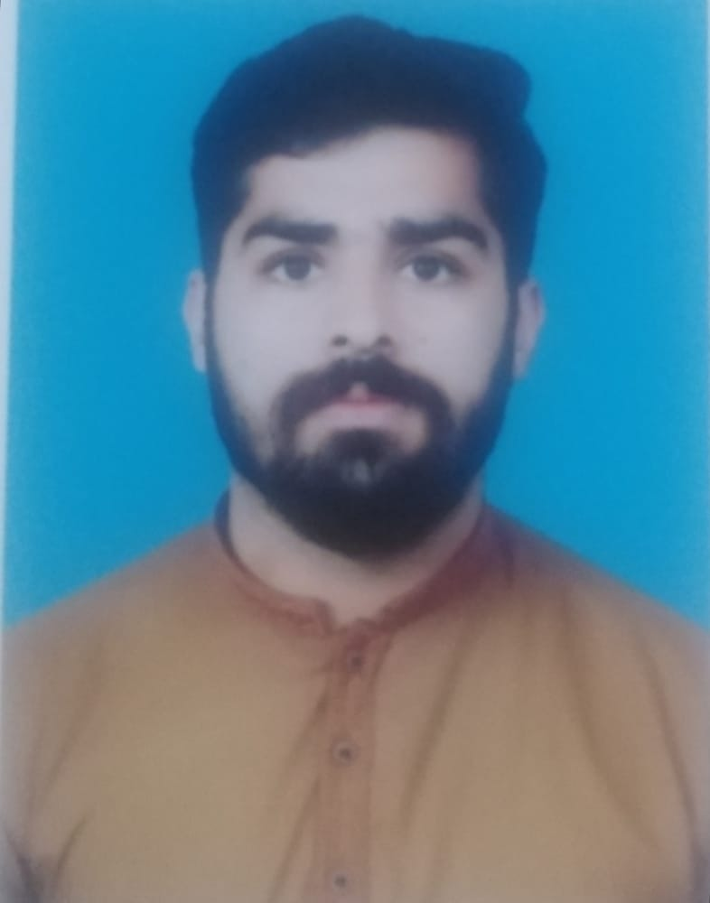

Date of Birth 04/02/2001
Business Address CS & IT Department
University of Sargodha University Road, Sargodha, Pakistan Tel: +92-48-9230811 Ext: 365
Cell: 030012131213
Email: placement@csit.uos.edu.pk

